**CHRIS HUGHES**

**Builth Wells**

**Plate Winner 2017**

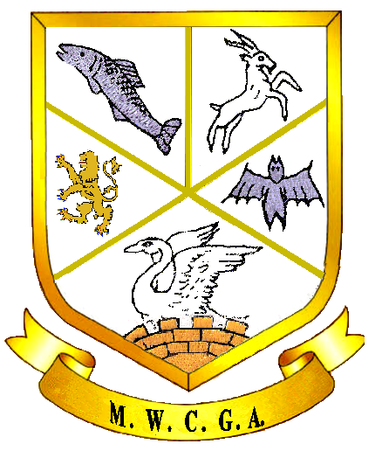

***Mid Wales County Golf Association***

***Championship Plate Competition 2017***

Ronnie Creswell

Chris Hughes

Hayley Price

Ronnie Creswell

Kara Parker

Chris Hughes

9

Chris Hughes, Builth

16

11

Mags Jones, Cradoc

14

Kara Parker, Builth

12

Ronnie Creswell, Cradoc

13

Ann Newell, Welshpool

15

10

Hayley Price, Builth